**Department of Electrical Engineering**

|  |  |
| --- | --- |
| **Faculty Member: Ma’am Qurat-ul-Ain** | **Dated: December 31, 2020** |
|  |  |
| **Course/Section: BSCS-9B** | **Semester: 3rd** |
|  |  |

**Computer Organization and**

**Assembly Language (CS235)**

**Lab #12 Use of Some Digital/Analog Sensors with Arduino Uno on Tinkercad**

|  |  |  |  |  |  |  |  |
| --- | --- | --- | --- | --- | --- | --- | --- |
|  | | **PLO4** | | **PLO5** | **PLO8** | **PLO9** |  |
| **Name** | **Roll number** | **Viva /Quiz/ Lab performance**  **5 marks** | **Analysis of data in lab report**  **5 marks** | **Modern tool Usage**  **5 marks** | **Ethics and Safety**  **5 marks** | **Individual and team work**  **5 marks** | **Total**  **25 marks** |
| **Fatima Seemab** | **291310** |  |  |  |  |  |  |
| **Mahum Samar** | **290647** |  |  |  |  |  |  |
| **Maryam Fatima** | **290479** |  |  |  |  |  |  |

**Objective**: The objective of this lab is to learn about use of some sensor with Arduino.



RGB led





Servo motor.



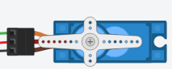

PIR motion sensor:



Average detection **range** is between 5m and 12m.



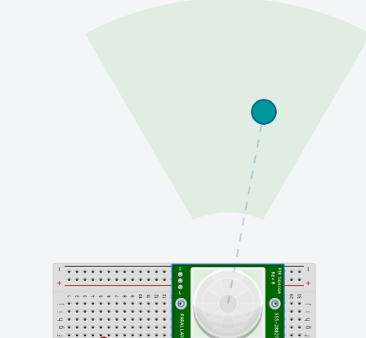

**Task1:**

In this task, we will create a lamp that changes its color depending on the room's lighting conditions.

For this, we will use RGB Led and three photo resistors. RGB led has 3 terminals Red, green, and blue which will be connected with three analog output pins for this task. Three photo-resistors connect with three analog input pins. Maximizing the value of photo-resistor1, particular output pin (output pin that is getting the photo-resistor1 value) gets max value and respective color (either red, or blue or green) will be displayed on RGB led. By maximizing two photo resistors, two color will be mixed up on RGB led. By maximizing all photo-resistors, RGB led will display white color. In output, you will display white color. Also print the values of all photo-resistors using serial print command.



Serial.begin(9600); // used in setup function



Serial.print()// used in loop function



Photo-resistors-> connect with analog pins -> mapping with analog output by dividing each photo-resistor value by 4 -> sending signals to output-> connection with RGB



**Code:**

int sensor0;

int sensor1;



int sensor2;

void setup()

{

pinMode(A0, INPUT);

pinMode(9, OUTPUT);



pinMode(A1, INPUT);

pinMode(10, OUTPUT);



pinMode(A2, INPUT);



pinMode(11, OUTPUT);

Serial.begin(9600);

}

void loop()

{

 sensor0 = analogRead(A0)/4;



sensor1 = analogRead(A1)/4;



sensor2 = analogRead(A2)/4;



analogWrite(9, sensor0);



analogWrite(10, sensor1);



analogWrite(11, sensor2);

Serial.print("sensor0: "); Serial.println(sensor0);

Serial.print("sensor1: "); Serial.println(sensor1);



Serial.print("sensor2: "); Serial.println(sensor2);

}

**Circuit:**

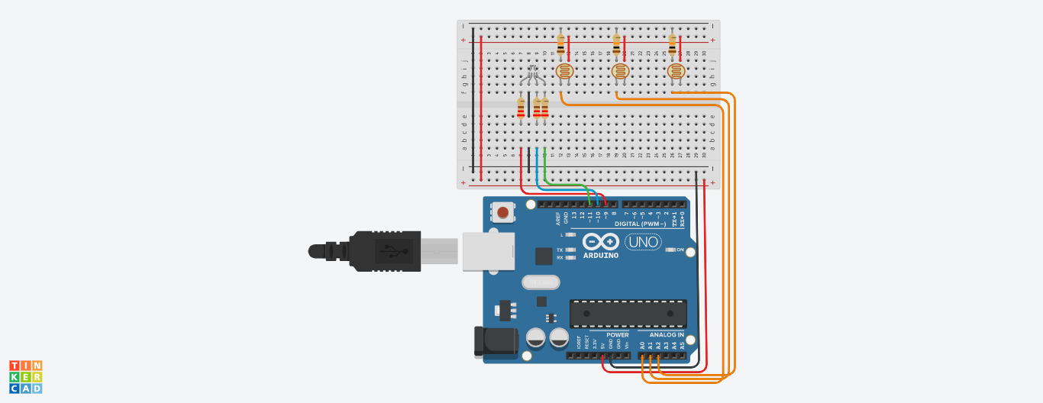



**Link:**

<https://www.tinkercad.com/things/fmx3BzIh42F-lab12t1/editel?sharecode=UANXu_VnNIe4dzI5ZDw1Ol9-xulTmcTdUU_ji1gBXao>

**Task2:**

In this task, you will use servo motor and will control servo motor angle with potentiometer. Servo motor angle can change from 0 to 180. With min value of potentiometer, servo show min angle i.e., 0 , as potentiometer value increases servo meter angle increases, and when potentiometer value will be maximum, your servo meter angle will be maximum (i.e, 179).



#include <Servo.h>



Servo myServo;

void setup()

{

myServo.attach(pinnumber); //tells board which pin the servo is attached

Serial.begin(9600); //Baud rate for serial printing

}

// the loop routine runs over and over again forever:

void loop() {

map(value, fromLow, fromHigh, toLow, toHigh)



e.g., var1 = map(x, 0, 50, 100, 200);

//You will use map function for nagle mapping. Angle is the pot value re-scaled to 0-179 degrees



myServo.write(angle_val); //writing angle to servomotor

}

**Code:**

#include <Servo.h>

Servo myServo;

int angle;



int value;

void setup()

{



myServo.attach(11);



pinMode(A0, INPUT);

Serial.begin(9600); //Baud rate for serial printing

}

void loop() {

value = analogRead(A0);

angle = map(value, 0, 1023, 0, 180);

myServo.write(angle);

Serial.print("Value of Potentiometer: "); Serial.println(value);

Serial.print("Angle of Servo meter: "); Serial.println(angle);

}

**Circuit:**

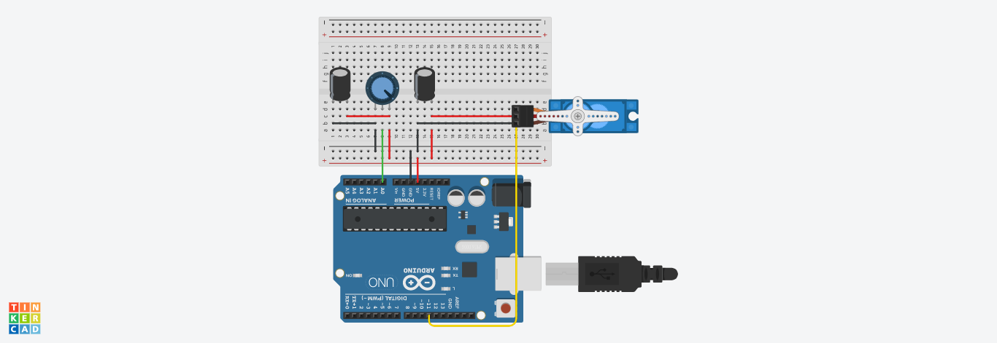



**Link:**

<https://www.tinkercad.com/things/aaNvzUVafP3-lab12t2/editel?sharecode=khg5IPLh0TwN1yZAAyuD8Is9zXwxxEUuWgeZW-Mo1PQ>

**Task3:**

We will use PIR sensor for motion detection. If PIR sensor detected a motion, LED will be on, and led will remain on for 1 second and after this led will be off. If PIR sensor does not detect any motion, LED will be off. PIR sensor is a digital sensor, which give value high if it detects motion, other give value low.

See connections below,

**Code:**

bool detect;

void setup()

{

pinMode(13, OUTPUT);

pinMode(7, INPUT);

}

void loop()

{

detect = digitalRead(7);

digitalWrite(13, detect);

if(detect)

delay(1000); // Wait for 1000 millisecond(s)



}

**Circuit:** 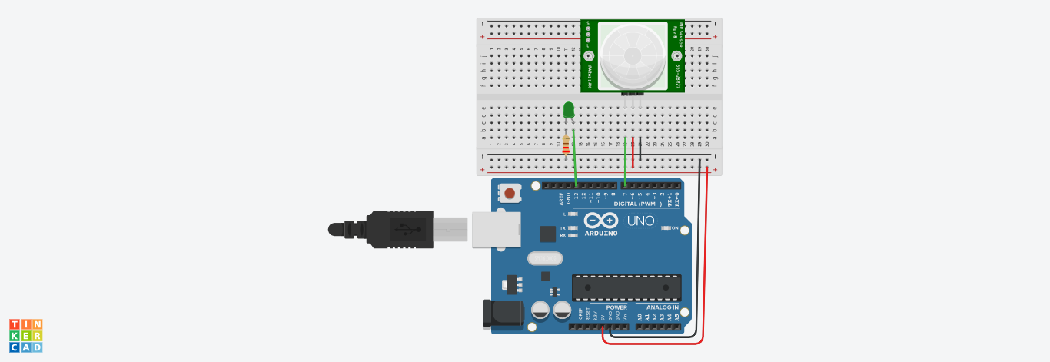

**Link:**

<https://www.tinkercad.com/things/67jRHM2lWh4-lab12t3/editel?sharecode=RULSgXA-TuFzXN3LDf7bcuEMhoGw0XmuG5JeQFLtiKE>